A Survey on the Semi-automated Serious Educational Games for
a New Approach in the SimSYS Serious Educational Game Development Platform

TR xxxxx

Dr. Kendra Cooper

Golsa Mirbagheri

Acknowledgements

xxx.

Abstract

yyy.

Table of Contents

Acknowledgements ii
Abstract iii
Table of Contents iv
1. Introduction 6
2. Comparison Criteria 7
2.1 Validation: Serious Educational Game Assessment 7
2.2 Serious Educational Game Customization 7
2.3 Serious Educational Game Automation 7
2.4 Pedagogical foundation on Serious Educational Games 8
2.5 Serious Educational Games Content Generation 8
3. Game Development in Education Automatic and Semiautomatic Methodologies 9
3.1 Fully Automatic Adaptation of Interfaces - The case of 1492 9
3.1.1 Introduction 9
3.1.2 Comparison Criteria 10
3.2 Semiautomatic Adaptation - The case of "My first day at work" 10
3.2.1 Introduction 10
3.2.2 Comparison Criteria 12
4. Automating e-Learning: The Higher Education Revolution 13
4.1 Introduction 13
4.2 Automating e-Learning 14
4.2.1 Comparison Criteria 15
5. An Offline Planning Approach to Game Plotline Adaptation 15
5.1 Introduction 15
5.2 The Architecture of the Proposed System 16
5.2.1 Comparison Criteria 18
6. Table of Comparison Criteria 19
7. Your solution 20
7.1 Introduction 20
7.2 Detailed description 20
7.2.1 subheading 20
7.2.2 subheading 20
7.3 Tool Support 20
7.3.1 subheading 20
7.4 Validation results 20
7.4.1 subheading 20
7.4.2 subheading 20
7.5 Conclusions 20
8. Conclusions and Future Work 21
8.1 subheading 21
8.1.1 subheading 21
8.1.2 subheading 21
8.2 subheading 21
8.2.1 subheading 21
8.2.2 subheading 21
9. References 22
Appendix A. title here 24

Introduction

// a place to start is one paragraph for each of these:

Intro. to changing educational needs, how e-learning fits into that shift (include definition with reference for e-learning)
Intro. to serious educational games (include definition with reference of serious educational game)
Intro. to automation in serious education games (what other researchers have automated)
Intro. to the SimSYS Game Development Platform (overview, with references)
Focus in on the intelligent semi-automated game generation component
Why is this research needed?
Brief overview of the component, research methodology (including validation), and results
Structure of this report

Comparison Criteria

Validation: Serious Educational Game Assessment
Assessment has become a subject of great interest to engineering educators. This is part of a larger trend toward emphasizing student learning outcomes in higher education, undertaken both to demonstrate accountability and to improve instruction. Traditionally, engineering educators have focused assessment around students' mastery of content knowledge and skills. IEEE
Internal educational validity indicates to what extent learners achieve the learning/performance/skills expected by the game/simulation (e.g., decision-making skill, prediction accuracy, cooperation, motivation). The measures can be either the performance indicator provided by the game/simulation (e.g., total sales, total profit), or the ones designed based on the expected outcomes from the game/simulation. External educational validation refers to whether the learning/skills expected by the game/simulation matters or relevant in the real world? Representational validity is the basis of educational validity. However, a high representational validity does not necessarily lead to high educational validity. On the contrary, high representational validity (e.g., high fidelity and complexity) may lead to low educational validity (i.e., poor learning) for certain learners. Some people may approach the validation in a simpler way by assessing the game/simulation in terms of a series of desirable learning outcomes/skills, and see which one(s) the game/simulation is effective in improving.

Serious Educational Game Customization
User interfaces to games embody the practice and experience of interfacing users (game players) to both the game system and the play experience designed by the game's developers. Game developers act to constrain and govern what users can do, and what kinds of experience they can realize. Some users in turn seek to achieve a form of competitive advantage during game play by modding the user interface software for their game, when so enabled by game developers. These modes acquire or reveal additional information that users believe will help their play performance and experience. User interface add-ons subsequently act as the medium through which game development studios support game product customization, which is a strategy for increasing end-user satisfaction and thus the likelihood of product success.
Three kinds of user interface customizations can be observed. First and most common, is the player's ability to select, attire or accessorize a player's in-game identity. Second, is for players to customize the color palette and representational framing borders of their game display within the human-computer interface. Third, are user interface add-on modules that modify the player's in-game information management dashboard, but do not modify the underlying game play rules or functions.

Serious Educational Game Automation
Automated Verification System: A software tool that accepts as input a computer program and a representation of its specification and produces, possibly with human help, a proof or disproof of the correctness of the program. Any software tool that automates part or all of the verification process. IEEE
scientific methods and technologies that improve efficiency, productivity, quality, and reliability, specifically for methods, machines, and systems operating in structured environments over long periods, and the explicit structuring of environments. Research includes topics related to robots and intelligent machines/systems in structured environments and the explicit structuring of environments, and topics at the Operational/Enterprise levels such as System Modeling, Analysis, Performance Evaluation; Planning, Scheduling, Coordination; Risk Management; and Supply Chain Management. IEEE

Pedagogical foundation on Serious Educational Games
In pedagogical foundation on Serious Educational Game, 5 areas called prediction-observation-explanation (POE), Self-explanation, Collaboration, Problem-Based Learning (PBL) and Guidance, reflection, and interactivity will be evaluated.

- The prediction-observation-explanation (POE)
A prediction-observation-explanation model is a potential approach to increase learners’ conceptual change.
- Self-explanation
Self-explanation is a method that prompts students to generate their own explanation orally, in writing, or through replying to a multiple-choice question.
- Collaboration
Collaboration refers to a situation that two or more students work together on constructing knowledge and solving problems. In a game environment, collaboration enables players to guess and discuss about game moves, strategies, or arguments.
- Problem-Based Gaming (PBG)
Problem-Based Learning (PBL) is an ideal way to engage learners in cognitive processes so that they can build knowledge or develop skills to solve problems effectively.
- Guidance, reflection, and interactivity
The researchers conducted three experiments to investigate how students’ deep learning was enhanced in an agent-based multimedia game that integrates instructional methods: guidance (the agent explains why an answer is accurate), reflection (learners are prompted to explain why an answer is accurate), and interactivity (learners are asked to respond to a problem instead of receiving an answer from the agent). The results show that ether guidance or reflection was able to support students’ science learning in a game context. In addition, reflection also fostered retention and far transfer only when the students were encouraged to reflect on the correct solutions provided by the agent (interactivity). That is, if asked to reflect on their own solutions, the students might not benefit from playing the game.

Serious Educational Games Content Generation
Procedural content generation (PCG) is an increasingly important area of technology within modern human-computer interaction (HCI) design. Personalization of user experience via affective and cognitive modeling, coupled with real-time adjustment of the content according to user needs and preferences are important steps toward effective and meaningful PCG. Games, Web 2.0, interface, and software design are among the most popular applications of automated content generation. IEEE
Content creation involves work with the information structure, navigation, taxonomy and categorization of content. Content either needs to be created new from scratch, or must be imported from an existing Web site, or both. Content creation can start when the editors are prepared, and when the technical environment is sufficiently ready. The content work will then most likely continue beyond the technical delivery and acceptance of the Web site. Content can be of many kinds but is typically text and images in different formats – web pages, documents (Word, pdf...), sounds, animations etc. Normally the customer manages the content input to the new Web site, but the partner may also assist in this part. In most cases it is not a problem to work with content and development at the same time on the test server, as long as user have an active communication in the project team so that everyone is aware of what is going on.

Game Development in Education Automatic and Semiautomatic Methodologies

In this section the need for tools will be discussed that assist educators and educational content providers in producing games that are equally accessible for all. The goal is to minimize the cost and effort needed for introducing accessibility in serious games. It will be discussed to what extent the process of making a serious game accessible can be automated and supported by software tools that minimize human intervention. It is concluded that there is a set of common accessibility barriers, especially those related to interaction and physical disabilities that can be addressed systematically in a high proportion and therefore could be dealt with by software.

Fully Automatic Adaptation of Interfaces - The case of 1492

Introduction
In this section two user profiles are considered: blind users and users with a motor disability. Among the wide variety of levels of visual impairments, it’s characterized the blind user profile as users that needed the aid of screen reading software to use a computer. Users with a motor disability as those needed of using voice recognition software to interact with a computer due to reduced or lack of mobility. Both user profiles encounter barriers when interacting with point-and-click applications as they are not able to use the mouse.
The game author was only allowed to enable or disable the modules during the exportation process. All the adaptation to the user profile was performed automatically by analyzing the game description XML files and art resources (see Fig.3.1).
The results were two new modalities which had common inner workings. The interaction was performed through short commands formulated in natural language (e.g. "grab the notebook" or "talk to the character"). An interpreter received the commands, executed them if they were correct, and provided feedback about the results using the appropriate channel for the active user profile (auditory for the blind user through a built-in text-to-speech engine, text for the user with a motor disability). Blind users introduced the commands using the keyboard, while users with a motor disability used speech [3].
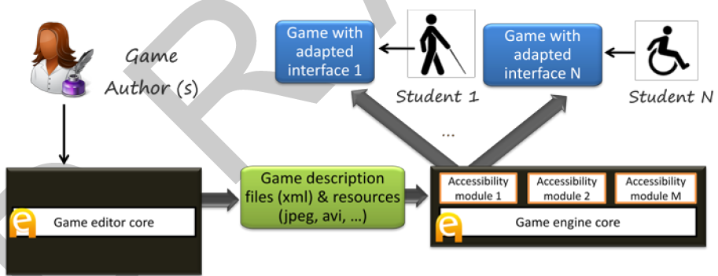
Game engine Core

…
Accessibility module 1
Accessibility module M
Game editor Core
Game description files and resources Core
Game Author

Game with adapted interface 1
Game with adapted interface N

Student 1
Student 2
Fig 3.1. Basic accessibility architecture. Accessibility was provided by specific input/output modules integrated with the engine, which are activated when the game was exported [3].
Command processing was directed by a regular grammar combined with a fixed list of synonyms for relevant verbs (actions) and nouns (interactive elements). The regular grammar was automatically generated from the description of the game, taking the actions defined for the interactive elements available in each game scenario.

Comparison Criteria

Validation: Serious Educational Game Assessment
No validation module has been implemented in this approach.

Serious Educational Game Customization
The goal is to minimize the cost and effort needed for introducing accessibility in serious games. In accessibility architecture. Accessibility was provided by specific input/output modules integrated with the engine, which are activated when the game was exported [3].

Serious Educational Game Automation
In the case of 1994, all the adaptation to the user profile was performed automatically by analyzing the game description XML files and art resources. The regular grammar was automatically generated from the description of the game, taking the actions defined for the interactive elements available in each game scenario. (refer to table)

Pedagogical foundation on Serious Educational Games
In this approach no pedagogical foundation method is used.

Serious Educational Games Content Generation
In this approach no method is used for creating content.

Semiautomatic Adaptation - The case of "My first day at work"

Introduction
Another experiment which was resulted in the game "My first day at work", developed in collaboration with Technosite, a company of the ONCE (National Organization for the Blind in Spain) group. In Fig. 3.2, flexibility of the accessibility features was improved that now could be configured with the game editor [3].
In addition to the blind and motor disability profiles, a new user profile was considered: users with low vision. Colleagues from Technosite identified the adaptations this profile needed, which included screen and text magnification and use of a high contrast color scheme.
"My first day at work" was focused on meeting the needs of the three be-spoken profiles (blind, motor disability and low vision), it has been tried to make it accessible to users with cognitive disabilities (e.g. Down and Asperger syndromes).

Game editore Core

……..
...
..

…
Additional description files (xml) + alternative resources
Game Author
Access config tool 1

Game engine Core

…
Game description files and resources Core
Accessibility module 1
Accessibility module M
Access config tool X
Game with adapted interface 1
Game with adapted interface N

Student 1
Student 2
Fig. 3.2. Improved architecture and workflow. The accessibility features are now configurable from the editor to match different user profiles. The editor also produces automatically additional description files and resources [3].
Dealing with these problems is much more complicated and there is little room for automation. The eAdventure adaptation engine was used to provide alternative paths in the game with different levels of difficulty, or alternative versions of text intensive components such as conversations [3].

Level of automatic and semi-automatic adaptation
Table 1 shows a summary of the adaptations performed. Adaptations related to the modality, how the user interacts with the game or perceives the game feedback are prone to be automated (e.g. interfaces for blind users and users with reduced mobility).
To make it accessible for users with low vision it was needed to produce alternative versions of 53 art resources, an increase of 7,57%. Although this value is not very high it could increase exponentially if more profiles were considered (e.g. users with color blindness), so it is important to keep the number of manually crafted alternative resources as low as possible [3].

Table 3.1. Summary of adaptations performed for each profile. Table reflects what aspect of the game were affected and the level of automation achieved[3].
Profile | Aspect | Adaption (s) | Automation
Blind | Interaction / modality | New interaction and adapted return of information | High
Motor disability | Interaction / modality | New Interaction | High
Low vision | Interface / rendering pipeline | High contrast rendering filters, magnification, alternative images and color schemes | Medium
Cognitive disability | Game design and content | Lessened difficulty of puzzles, alternative version of texts | Low

Comparison Criteria

Validation: Serious Educational Game Assessment
No validation module has been implemented in this approach.

Serious Educational Game Customization
The goal is to minimize the cost and effort needed for introducing accessibility in serious games. In accessibility architecture. Accessibility was provided by specific input/output modules integrated with the engine, which are activated when the game was exported [3].

Serious Educational Game Automation
In the case of "My first day at work”, the accessibility features are now configurable from the editor to match different user profiles. The editor also produces automatically additional description files and resources[3]. ( refer to table)

Pedagogical foundation on Serious Educational Games
In this approach no pedagogical foundation method is used.

Serious Educational Games Content Generation
In this approach no method is used for creating content.

Automating e-Learning: The Higher Education Revolution

Introduction

5th Generation Distance Education: The Emerging e-University
The fifth generation distance education (The Intelligent Flexible Learning Model) will not be presented solely as a set of abstract principles, but will be illustrated within the context of the e-University Project.
The Award, presented by the Prime Minister at Parliament House in Canberra, focused on the preparation of graduates of both undergraduate and postgraduate courses and the university as a whole for the emerging ‘e-world’: http://www.usq.edu.au/GUG2000.htm The e-University Project was conceptualized in terms of three fundamental foci: the e-Information repositories, a variety of e-Applications and the e-Interface respectively. A graphic overview of University of Southern Queensland (USQ)’s e-University Project is presented in Figure 4.1.

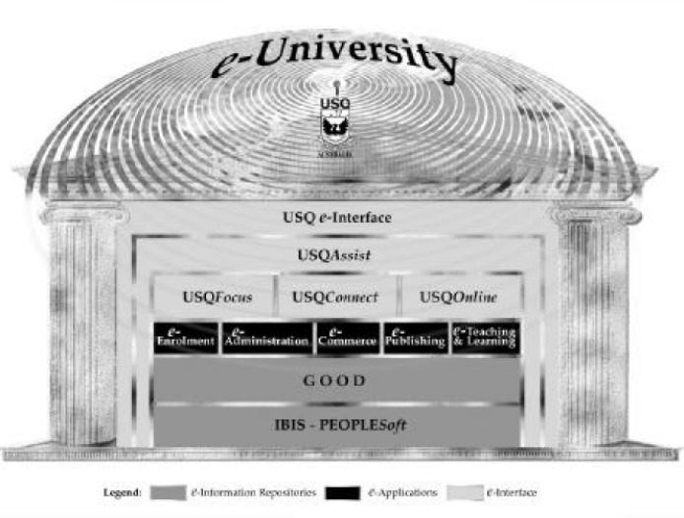
Fig. 4.1: Overview of USQ’s e-University Project.[4]

Learner Relationship Management
The USQAssist initiative is deploying tracking and automation tools to manage the interaction between the University and both its existing and prospective students. The most efficient, cost–effective way to manage the 24 x 7 challenge is to deploy effective automation tools, as opposed to running three shift student service desks or employing online tutors in different continents.
The deployment of e-Customer Relationship Management (e-CRM) software as “Learner Relationship Management” will ultimately enable the use of a single toll free number integrated with an email–based enquiry tracking system that will exploit the fundamental strengths of the Internet in enhancing communication and managing information. The USQ e-interface is being developed through the application of a web services approach. The implementation of the approach has entailed the creation of an Internet Systems Design, Development and Integration Team, and an Online Systems Technical Management Committee (OSTMC).
The OSTMC also provides a useful forum to support the implementation of USQ’s on campus wireless networking initiative http://www.usq.edu.au/its/wireless.

Automating e-Learning
In the USQ approach, many teaching staff make use of discussion groups, which entail students posting “reflections” via the asynchronous computer mediated communication (CMC) system. The teaching staff also post comments.
In the same vein, members of the teaching staff respond to student questions posted to the discussion group. Further, our experience demonstrates that other students often comment on the issues raised thereby enriching the depth and quality of the dialogue. The value of these contributions is particularly useful where students are giving examples of applications in different cultural contexts. While such fears can be allayed by the use of “one-to many” communication systems such as bulletin boards, mailing lists and threaded discussions, the underlying resource model is not significantly different from conventional on campus teaching, with a staff member being necessary to manage groups of approximately 20 students to maintain a reasonable quality of interaction and academic support. In contrast, the fifth generation Intelligent Flexible Learning Model has the potential to deliver major economies of scale in managing teaching and academic support through the exploitation of automated response systems (Fig 4.2)[4].
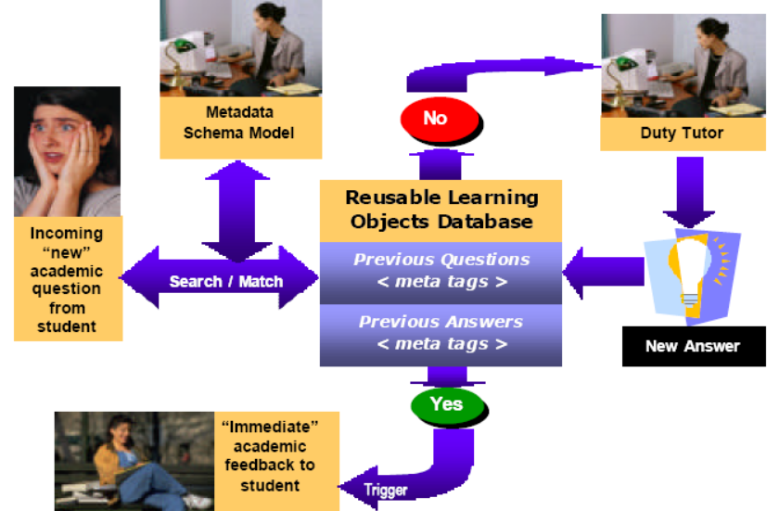
Fig. 4.2: Schematic representation of USQ’s 5th Generation Academic Productivity Enhancement System[4]

Upon receipt of an electronic query from a student, the staff member references the incoming question to a metadata schema model which has been devised for the course in question; the search engine then seeks an appropriate match with a previously asked question, which if successful, triggers a potential range of answers to the current question without further human intervention.
At this stage of development, the design of the system entails a tutor checking the validity of the match between the current question and the answers generated from the database before forwarding to the students with a single click of the mouse. Such a quality control mechanism may become redundant in the future. If no appropriate match is discovered in the database of previously answered questions, the query is automatically routed to the relevant tutor for an appropriate response, which is then added to the database with a single point and click.
Depending on the pedagogical design of the course, these responses can be directed to the whole cohort of students, to groups of students, or to individuals. The system has the advantage of providing more-or-less immediate pedagogical advice to students, a significant increase in institutional responsiveness, at minimal variable cost. It is worth noting that this system is not just aimed at reducing costs, USQ has a research program producing empirical evidence aimed at to validating the potential pedagogical efficacy of the approach, as illustrated by the following brief discussion of underlying instructional design theory and an associated exemplary investigation[4].

Comparison Criteria

Validation: Serious Educational Game Assessment
At the stage of development, the design of the system entails a tutor checking the validity of the match between the current question and the answers generated from the database before forwarding to the students with a single click of the mouse.

Serious Educational Game Customization
As mentioned before, no accessibility was used to minimize the cost and effort needed for student with physical problems.

Serious Educational Game Automation
The USQAssist initiative is deploying tracking and automation tools to manage the interaction between the University and both its existing and prospective students. The design of the system entails a tutor checking the validity of the match between the current question and the answers generated from the database[4].

Pedagogical foundation on Serious Educational Games
The system has the advantage of providing more-or-less immediate pedagogical advice to students, a significant increase in institutional responsiveness, at minimal variable cost. It is worth noting that this system is not just aimed at reducing costs, USQ has a research program producing empirical evidence aimed at to validating the potential pedagogical efficacy of the approach, as illustrated by the following brief discussion of underlying instructional design theory and an associated exemplary investigation[4].

Serious Educational Games Content Generation
In this approach no method is used for creating content.

An Offline Planning Approach to Game Plotline Adaptation

Introduction
Role-playing games, and other types of contemporary video games, usually contain a main storyline consisting of several causally related quests. As players have different motivations, tastes and preferences, it can be beneficial to customize game plotlines. In this section, an offline algorithm for adapting human-authored game plotlines for computer role-playing games will be presented to suit the unique needs of individual players, thereby customizing gaming experiences and enhancing re-playability. On-demand entertainment refers to the possibility that one can, at any time, request an entertainment experience that is significantly different from those previously consumed. In addition, entertainment artifacts should be customized or configured to suit every player’s unique motivation, tastes, history and ability. This section addresses on-demand and customized entertainment in the context of generating plotlines for role-playing games.
The contribution of this section is a system that solves the plotline adaptation problem: Given a complete, human-authored plotline consisting of sequence of quests, a library of quest structures, and a set of requirements about what an optimal gameplay experience should be for a particular user at a particular time, produce a sound, coherent variation that meets the requirements while retaining as much of the original plotline as possible. Offline processing affords the possibility to making globally optimal decisions about plotline structures, complimenting online adaptation techniques known as interactive storytelling. The supposed technique is justified with a discussion on theoretical authoring gains and empirical evaluation of our algorithm[5].

The Architecture of the Proposed System

Game Plot Adaptation
Figure 5.1 shows the adaptation pipeline for game plotlines. The game adaptation process takes a main plotline, a library of quest structures, and a set of player requirements as input. A player model generates a set of requirements, based on the player’s preferences, history, and a model of novelty. Importantly, the cycle between player and adaptation implies that games can be changed after each time it is played, thereby increasing its replayability. Possible actions in the virtual world are known to the system.
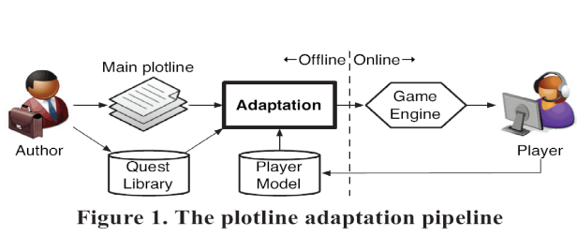
Figure 5.1. the plotline adaption pipeline

Plot Representation
Following others, the plan-like representations of narrative are employed because they capture causality and temporality of action and provide a formal framework built on first principles, such as soundness and coherence, for selecting and ordering events. However, unlike a plan meant for execution, it’s used plans as descriptions of events expected to unfold in a virtual world. Each action represents a formal declaration of an event that can be performed by the player or non-player characters, or occurs as a consequence of physics laws in the virtual world.
The specific representation builds on partial-order plans. In this system, quests are represented as top-level abstract events. A quest has a single effect, guest complete (guest-X), and may or may not have any preconditions. Figure 5.2 shows a complete plotline consisting of two quests. Primitive actions are shown as solid rectangles and abstract actions are shown as rounded rectangles. The hierarchical relationship between events is reflected in the containment relationships of rectangles.
A coherent narrative is one in which, in the DAG formed by events and causal links, there is a path from each event to a significant outcome. Any event that is not part of some path to the outcome situation is referred to as a dead end[5].

Player Model
The player's preferences are modeled as a function of previously selected quests. Each quest, in turn, is represented as a feature vector in a semantic space. A technique is utilized to determine preferences over quests via ratings after gameplay concludes. In addition, a novelty model favors quests that are appropriately novel to the player based on his or her history so that he or she would be neither bored nor unpleasantly surprised. Computing a weighted sum of utility by preference and utility by novelty, the result is the selection of the k quests with the greatest utility that should be included in the game plotline.

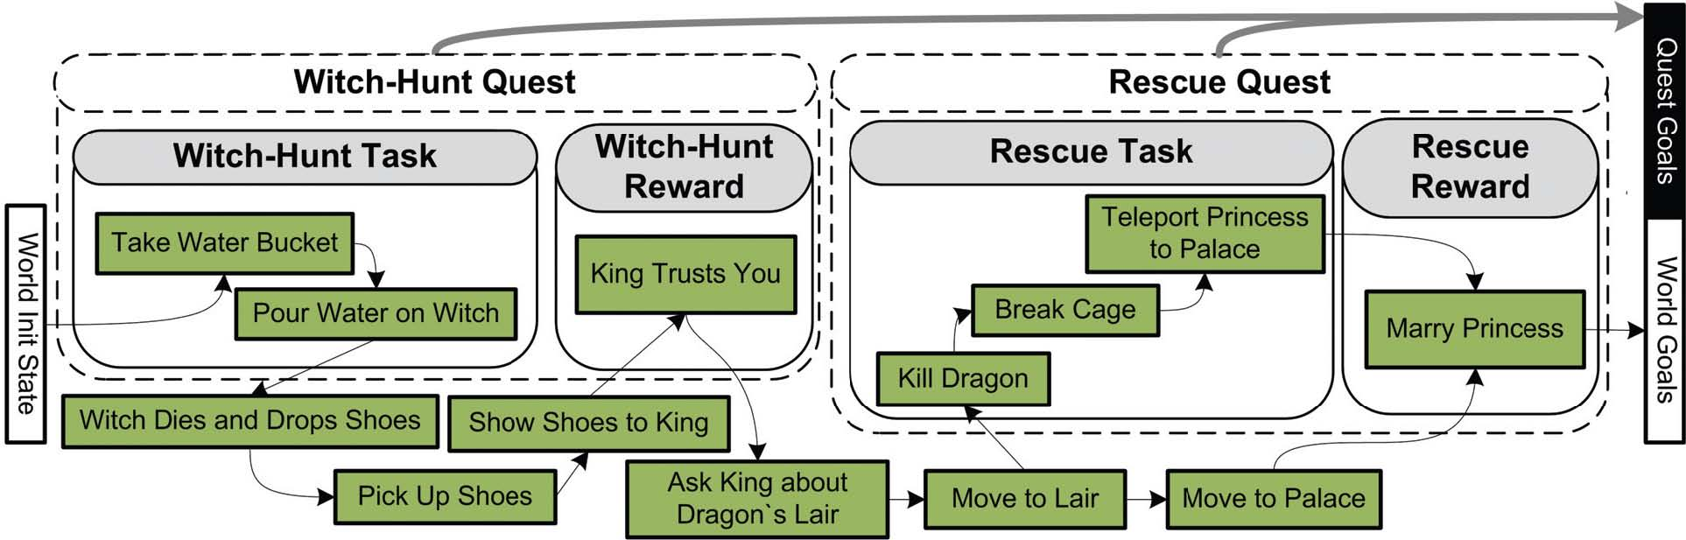
Figure 5.2. Original game plotline before adaptation[5]

Adaptation Algorithm

The plot adaptation module receives as input the following components:

- A complete plotline – a partially ordered, hierarchical plan – composed of events within and outside of quests.
- A set of plot requirements: guest complete (guest-X) propositions specifying what quests should be included, and corresponding world-level outcome propositions.

The adaptation algorithm is shown in Figure 5.3. The main loop is the standard plan refinement search loop.

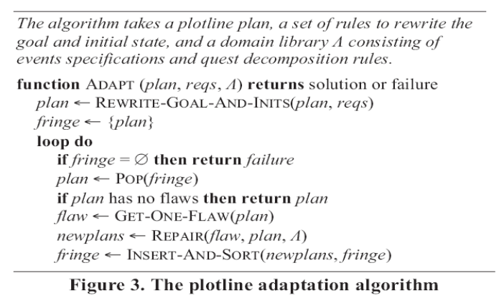
Figure 5.3. the plotline adaption algorithm

Plotline adaptation scales up the ability to deliver customized experiences without significantly increasing the authoring effort. The variability is focused– the number of distinct stories – as our metric.
A one-time authoring cost by a domain engineer is incurred in the development of a world domain model, containing specifications for primitive events, abstract events (including quests), and decomposition rules. The payoff is a theoretically exponential leverage. The adaptation process can theoretically produce as many variations of a given plotline as the size of the power set of available quests. Thus, one strength of plotline adaptation is the ability to opportunistically discover new transitions between quests based on the world model [5].

Comparison Criteria

Validation: Serious Educational Game Assessment
No validation module has been implemented in this approach.

Serious Educational Game Customization
In this section, an offline algorithm was presented for adapting human-authored game plotlines for computer role-playing games to suit the unique needs of individual players, thereby customizing gaming experiences and enhancing re-playability.

Serious Educational Game Automation
No automation method has been used in this approach.

Pedagogical foundation on Serious Educational Games
In this approach no pedagogical foundation method is used.

Serious Educational Games Content Generation
In this section, the use of automated content generation was explored as a means of scaling up the delivery of on-demand, customized entertainment content. In the realm of automated content generation, plotlines may be generated from scratch [5].

Table of Comparison Criteria

As mentioned previously, five approaches were compared to each other through 5 comparison criteria, which are shown in below table:

Table 6.1. Comparison Criteria

CC  Approaches | Validation | Pedagogical foundation | Customization | Automation | Content Generation
The case of 1492 |  |  | - Accessibility (by input/output modules integrated with the engine) | - analyzing the game description XML files and art resources
My first day at work |  |  | - Accessibility (by input/output modules integrated with the engine) | - Game editor core
Automating e-Learning | - tutor checking | - immediate pedagogical advice to students |  | - tracking and automation tools
An Offline Planning Approach to Game Plotline Adaptation |  |  | - offline algorithm for individual players |  | - plotline

Your solution

Introduction
// introduction for this section

Overview figure, architecture with description (inputs, processing, outputs)
Describe in terms of the comparison criteria

Detailed description
xxx

subheading
xxx

subheading
xxx

Tool Support

subheading

Validation results
xxx

subheading
xxx

subheading
xxx

Conclusions
// conclusions for this section

Conclusions and Future Work

subheading
xxx

subheading
xxx

subheading
xxx

subheading
xxx

subheading
xxx

subheading
xxx

References
// use correct format for book, journal, conference paper
// avoid websites
- Paul Flynn, Li Zhou, Kurt Maly, Steven Zeil, and Mohammad Zubair, Automated Template-Based Metadata Extraction Architecture, ICADL 2007, LNCS 4822, pp. 327–336, Springer-Verlag Berlin Heidelberg 2007.
- Javier Torrente, Ángel del Blanco, Ángel Serrano-Laguna, José Ángel Vallejo-Pinto, Pablo Moreno-Ger, Baltasar Fernández-Manjón, Towards Universal Game Development in Education Automatic and Semiautomatic Methodologies, Springer-Verlag Berlin Heidelberg 2011.
- A Model-Driven Framework to Support Development of Serious Games for Game-based Learning, School of Computing and Mathematical Sciences, Liverpool John Moores University, UNITED KINGDOM, 2010 Developments in E-systems Engineering, IEEE Computer Society, 2010 .
- Cheng-ping Chen, Ju-ling Shih, A Prototype on a Meta-model for Designing Instructional Pervasive Games, Department of Information and Learning Technology, National University of Tainan, 2012 Fourth IEEE International Conference On Digital Game And Intelligent Toy Enhanced Learning, 2012.
- Sara de Freitas, Learning in Immersive Worlds: A review of game-based learning, Prepared for the JISC e-Learning Programme.

Previous:

- C. Shaun Longstreet, Kendra Cooper, A Meta-model for Developing Simulation Games in Higher Education and Professional Development Training, IEEE 17th International Conference on Computer Games, Kentucky, USA ,2012
- S. Tang, M. Hanneghan, A Model-Driven Framework to Support Development of Serious Games for Game-based Learning, School of Computing and Mathematical Sciences, Liverpool John Moores University, UNITED KINGDOM, 2010 Developments in E-systems Engineering, IEEE Computer Society, 2010 .
- Cheng-ping Chen, Ju-ling Shih, A Prototype on a Meta-model for Designing Instructional Pervasive Games, Department of Information and Learning Technology, National University of Tainan, 2012 Fourth IEEE International Conference On Digital Game And Intelligent Toy Enhanced Learning, 2012.
- Sara de Freitas, Learning in Immersive Worlds: A review of game-based learning, Prepared for the JISC e-Learning Programme.
- Jeannette Bennett, Kendra Cooper, Lirong Dai, Aspect-oriented model-driven skeleton code generation: A graph-based transformation approach, Science of Computer Programming 75, pp: 689_725, 2010.
- Antti Kirjavainen, Development of Game-Based Learning Environments – Constructing a Quality Multi-Disciplinary Development Process, University of Jyvaskyla, Department of Mathematical Information Technology & Agora Center, Dissertation in Information Technology, October 6, 2009.
- Masoud Hemmasi, Lee A. Graf, Illinois State University, EDUCATIONAL EFFECTIVENESS OF BUSINESS SIMULATION GAMING:A COMPARATIVE STUDY OF STUDENT AND PRACTITIONER PERSPECTIVES, Development In Business Simulation & Experiential Exercises, Volume 18, 1991.
- S. Tang, M. Hanneghan, Fusing Games Technology and Pedagogy for Games-Based Learning Through a Model Driven Approach, School of Computing and Mathematical Sciences, Liverpool John Moores University, Liverpool, UNITED KINGDOM, 2011 IEEE Colloquium on Humanities, Science and Engineering Research (CHUSER 2011), Dec 5-6, Penang, 2011.
- Nathan Balasubramanian,Brent G. Wilson, GAMES AND SIMULATIONS, Society for Information Technology and Teacher Education (SITE), 2005.
- Tsung-Li Wang, Ya Fen Tseng, Learning Effect for Students with Game-based Learning on Meta-Analysis, The 6th International Conference on Computer Science & Education (ICCSE 2011), pp. 1291-1295, August 3-5, 2011. SuperStar Virgo, Singapore, 2011.
- Javier Torrente, Pablo Moreno-Ger, Baltasar Fernández-Manjón (2008). Learning Models for the Integration of Adaptive Educational Games in Virtual Learning Environments. Proceedings of the 3rd International Conference on E-learning and Games (Edutainment 2008), Nanjing, China. Lecture Notes in Computer Science 5093, pp. 463–474.
- Miroslav Minović, Miloš Milovanović, Mladjan Jovanović, Dušan Starčević, Model Driven Development of User Interfaces for Educational Game, HSI 2009 Catania, Italy, May 21-23, 2009
- Lina Marcela Morales, David Mendez-Acuna, Willy Montes, Model Driven Game Development - Case Study A MTC for maze game prototyping Departamento de Ingeniera de Sistemas y Computacion, Universidad de los Andes, Colombia.
- Marcio de O. Barros, Alexandre R. Dantas, Gustavo O. Veronese, Claudia M. L.Werner, Model-driven Game Development: Experience and Model Enhancements in Software Project Management Education, Softw. Process Improve. Pract. pp. 411–421. 2006.
- Miroslav Minovic, Milos Milovanovic, Dusan Starcevic, Modelling Knowledge and Game Based Learning: Model Driven Approach, Journal of Universal Computer Science, vol. 17, no. 9 pp. 1241-1260. 2011.
- Diana Oblinger, Simulations, Games, and Learning, EDUCAUSE, May 2006.
- STEPHEN TANG, Martin Hanneghan, State of the Art Model Driven Game Development: A Survey of Technological Solutions for Game-Based Learning, Journal of Interactive Learning Research (201 1) 22(4), pp: 551 -606.
- Josephine M. Randel, Barbara A. Morris, C. Douglas Wetzel and Betty V.Whitehill, The Effectiveness of Games for Educational Purposes: A Review of Recent Research, Simulation & Gaming, 1991.
- Kendra Cooper, C. Shaun Longstreet, Towards Model-driven Game Engineering for Serious Educational Games: Tailored Use Cases for Game Requirements, IEEE 17th International Conference on Computer Games, Kentucky, USA ,2012.

Appendix A. title here

